

sistema asistencia

Documentation



October 5, 2019

Department of Computer science

Atmiya University

Table of Contents

Project Profile 8

SPECIFICATION 9

Project Directory Structure 11

SYSTEM ANALYSIS 12

Existing System 12

Drawbacks of existing system: 12

Requirements of New System 12

Advantage Of New System 12

User requirement: 13

Feasibility Study: 13

Use case 16

What is a use case diagram? 16

When to apply use case diagrams? 16

UML use case diagrams are ideal for: 17

Use case diagram components 17

Use case diagram symbols and notation 17

System 18

Use Case: 18

Actors: 18

Relationships: 18

Use case diagram for Attendance system 19

Drawing Tool Used- : **Draw*.*io** 20

NodeJS 21

What is Node.js? 21

Why Node.js? 21

What Can Node.js Do? 21

What is a Node.js File? 22

Node Package Manager 23

What is NPM? 23

More on NPM? 23

What is a Package? 23

Use NPM to 23

Install Node.js & NPM on Windows 24

USER INTERFACE 28

What is User Interface Design? 28

There are 3 issues / parts of a user interface design, these being 28

Key Components of UI/UX Design 29

Interaction Design 30

Usability 30

Wire framing 30

Visual Design 30

Screenshots 32

Data Flow Diagram – DFD 43

Physical and logical data flow diagrams 43

Symbols and Notations Used in DFDs 43

Data flow diagram Systema Asistencia 46

Data Dictionary 49

Teachers: 50

Students: 50

Attendance: 51

PUG 52

What is Pug | Jade 52

Pug.js to make your life easier with HTML templates 52

Let’s see how pug code looks like. 53

PUG Structure | index.pug vs. index.html 53

Frameworks & Libraries 54

Express js 54

TypeORM 54

JWT 54

FaceAPI 55

TypeScript 55

**ACKNOWLEDGEMENT**

Sistema Assentensia **|** NodeJS

Date:

To Whom It May Concern:

I would like to highlight the fact that this project is the product of many contributors. First, I’d like to thank Professor **Chiraj Jagani** who accepted to work with me on my Project idea, supervising my work.

Second, I would like to thank the **Google**, **Youtube**, **stack overflow** community for providing tremendous help to the elaboration of this project.

abstract

Sistema Assentensia **|** NodeJS

Student attendance management system deals with the maintenance of the student's attendance details. It generates the attendance of the student on basis of presence in class. It is maintained on the daily basis of their attendance. The staffs will be provided with the separate username & password to make the student's status. The staffs handling the particular subjects responsible to make the attendance for all students. Only if the student present on that particular period, then the attendance will be calculated. The students attendance reports based on weekly and consolidate will be generated.

introduction

Sistema Assentensia

**Overview**

* THE ONLINE ATTENDANCE SYSTEM focuses on creating effective assessment of the applicant. This project will enable educational institutes to take an attendance and add teachers and students. This is specially designed for conducting digital Attendance
* Here principal can add faculties and students and can see the attendance taken by the teachers, in the filtering forms.
* Here, faculty have rights to add students and can also take attendance by capturing or adding a photograph and can see the attendance taken by the them , in the filtering forms.
* It can be conducted for remote attendance and can take attendance fully automated. This site is an attempt to remove flaws of existing forms or patterns of taking attendances

**introcuction**

Sistema Assentensia

**Purpose**

The primary objective of the program is to effectively assess the applicant thoroughly through a completely automated system that not only helps you to save a lot of time but also gives quick outcomes. It is a cost-effective and well-known indicates of mass- assessment program.

Systema Asistencia will reduce the hectic job of taking attendances of the students.

Will reduce paper work, Can generate daily or weekly or monthly attendance reports instantly as and when required.

Systema Asistencia is designed for educational system institutes like schools, colleges and private institutes to take attendances of their students on regular basis.

This project will be very helpful for educational institutes where regular evaluation of student’s is required. Further it can also be useful for anyone who requires feedback of regular present and absent.

# Project Profile

|  |  |
| --- | --- |
| Project Profile | |
|  |  |
| Name | Sistma Assentensia |
| Institute | Atmiya University |
| Department | Department of Computer Science |
| Semester | Sem 3 |
| Developed By | Dipen Pamar, Priyanka Maheta |
| Project Guide | Chiraj Jagani |
| Submitted to | Mscit |
|  |  |
|  |  |
|  |  |
|  |  |

# SPECIFICATION

|  |  |
| --- | --- |
| Project Specification & Technical Details | |
|  |  |
| Operating System | Windows, Mac, Linux |
| Web Technology | NodeJS |
| Web Server | Apache Server |
|  |  |
| Front End | HTML5, JS, Bootstrap |
| Back End | Nodejs, TypeScript, PugJS |
| Database | MySQL |
| Framework | ExpresJs, Bootstrap |
| Libraries | TypeORM, JWT, FaceAPI, |
| IDE, Text Editor | Web Strome, VsCode |
| Dev Tools | nodemon, ts-node-dev |
| Browser | Chome 50+, Firefox 40+ |
|  |  |

# Project Directory Structure

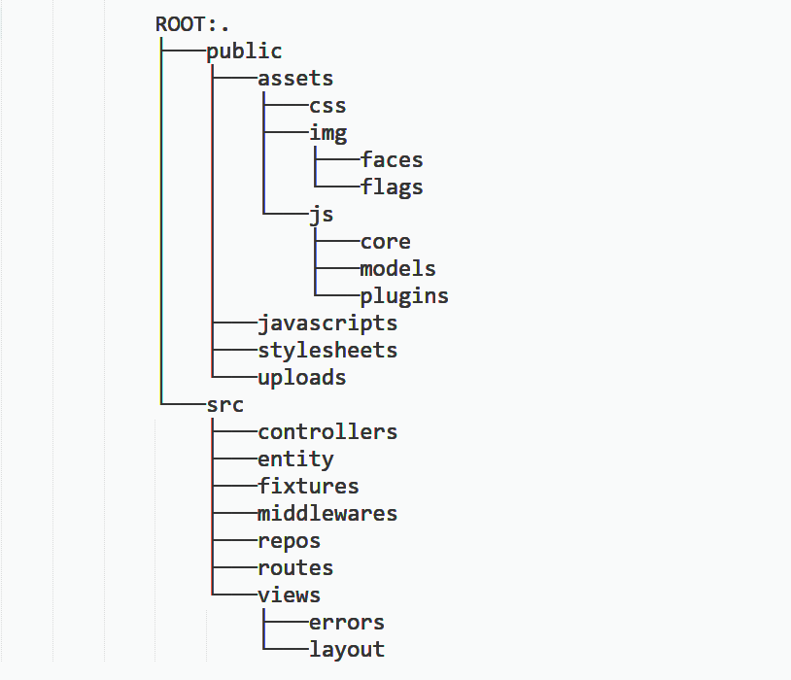

# SYSTEM ANALYSIS

## Existing System

Existing system is a manual one in which users are maintaining books to store the information like Student Details, Instructor Details, Schedule Details and feedbacks about feedbacks about faculties who took attendances as per schedule. It is very difficult to maintain historical data

## Drawbacks of existing system:

* A lot of copies of attendance sheets have to be made.
* A lot of correction work hence delay in giving the reports of present and absent.
* A lot of tabulation work for daily attendances.
* Very time consuming.

## Requirements of New System

Existing system is a paper based. It is very difficult to assets because instructor need to take attendance of all the students by preparing sheets. It is very difficult to main historic data. It is time consuming and costly as copies of paper have to made.

So to overcome all this disadvantages we required Eco-System which will reduce problems. And It not will be time consuming process.

## Advantage Of New System

* It is ECO-FRIENDLY SYSTEM.
* Easy to maintain records.
* No need to assets paper.
* Allows automatic generation of attendance sheets in filtering forms.
* Generates report of present and absent of students.
* Allows you to take attendances by capturing and adding a photo..
* From anywhere user can access this site within internet, intranet.
* Totally responsive site.

## User requirement:

* User should have technical knowledge to access this site.
* Individual Faculties must have individual device to take attendance

## Feasibility Study:

The feasibility study is the important step in any software development process. This is because it makes analysis of different aspects like cost required for developing and executing the system, the time required for each phase of the system and so on. If these important factors are not analyzed then definitely it would have impact on the organization and the development and the system would be a total failure. So for running the application and the organization successfully this step is a very important step in a software development life cycle process.

(1) Technical Feasibility:-

If internet connection is slow than it will take time to load the site. User should have technical knowledge to access this site.

(2) Economic Feasibility:-

No extra charges are required to access this system. Due to hosting charges sometimes it becomes costly, it is totally depending upon which plan you are selecting and for how much time

(3) Operational Feasibility:-

It is very interactive and user friendly. Easy to navigate and access. This site is compatible will the devices like mobile, tablet, etc.)

(4) Social Feasibility:-

This type of feasibility studies are conducted to determine the degree to which the design or location of a given project is socially justified.

# Use case

A use case describes how a user uses a system to accomplish a particular goal. A use case diagram consists of the system, the related use cases and actors and relates these to each other to visualize: what is being described? (System), who is using the system? (Actors) and what do the actors want to achieve? (Use cases), thus, use cases help ensure that the correct system is developed by capturing the requirements from the user's point of view.

## What is a use case diagram?

In the Unified Modeling Language (UML), a use case diagram can summarize the details of your system's users (also known as actors) and their interactions with the system. To build one, you'll use a set of specialized symbols and connectors. An effective use case diagram can help your team discuss and represent:

* Scenarios in which your system or application interacts with people, organizations, or external systems
* Goals that your system or application helps those entities (known as actors) achieve
* The scope of your system

## When to apply use case diagrams?

A use case diagram doesn't go into a lot of detail—for example, don't expect it to model the order in which steps are performed. Instead, a proper use case diagram depicts a high-level overview of the relationship between use cases, actors, and systems. Experts recommend that use case diagrams be used to supplement a more descriptive textual use case.

UML is the modeling toolkit that you can use to build your diagrams. Use cases are represented with a labeled oval shape. Stick figures represent actors in the process, and the actor's participation in the system is modeled with a line between the actor and use case. To depict the system boundary, draw a box around the use case itself.

## UML use case diagrams are ideal for:

* Representing the goals of system-user interactions
* Defining and organizing functional requirements in a system
* Specifying the context and requirements of a system
* Modeling the basic flow of events in a use case

## Use case diagram components

To answer the question, "What is a use case diagram?" you need to first understand its building blocks. Common components include:

**Actors:** The users that interact with a system. An actor can be a person, an organization, or an outside system that interacts with your application or system. They must be external objects that produce or consume data.

**System:** A specific sequence of actions and interactions between actors and the system. A system may also be referred to as a scenario.

**Goals:** The end result of most use cases. A successful diagram should describe the activities and variants used to reach the goal.

## Use case diagram symbols and notation

The notation for a use case diagram is pretty straightforward and doesn't involve as many types of symbols as other UML diagrams.

* Use cases: Horizontally shaped ovals that represent the different uses that a user might have.
* Actors: Stick figures that represent the people actually employing the use cases.
* Associations: A line between actors and use cases. In complex diagrams, it is important to know which actors are associated with which use cases.

System:  
 Draw your system's boundaries using a rectangle that contains use cases. Place actors outside the system's boundaries.

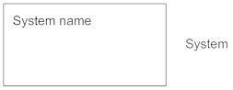

Use Case:  
 Draw use cases using ovals. Label the ovals with verbs that represent the system's functions.

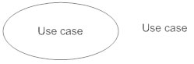

Actors: Actors are the users of a system. When one system is the actor of another system, label the actor system with the actor stereotype.

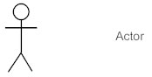

Relationships:

Illustrate relationships between an actor and a use case with a simple line. For relationships among use cases, use arrows labeled either "uses" or "extends." A "uses" relationship indicates that one use case is needed by another in order to perform a task. An "extends" relationship indicates alternative options under a certain use case.

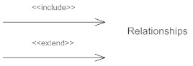

Src 1: <https://www.lucidchart.com/pages/uml-use-case-diagram>

Src 2: <https://www.smartdraw.com/use-case-diagram>

## Use case diagram for Attendance system

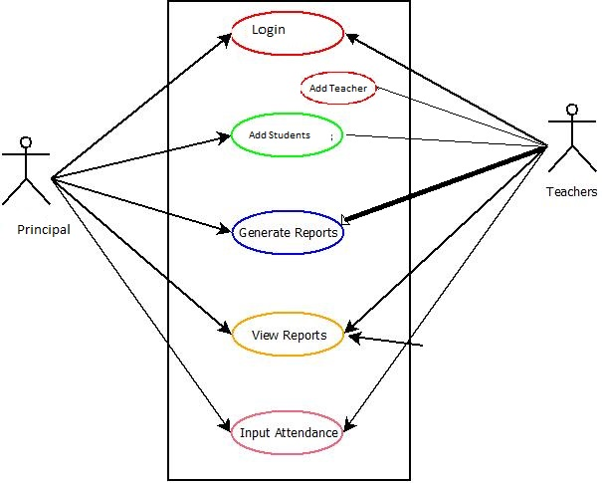

### Drawing Tool Used- : **Draw*.*io**

**Draw**.**io** is free online diagram software for making flowcharts, process diagrams, org charts, UML, ER and network diagrams.

Src: <https://www.draw.io/>

# NodeJS

## What is Node.js?

* Node.js is an open source server environment
* Node.js is free
* Node.js runs on various platforms (Windows, Linux, Mac OS X, etc.)
* Node.js uses JavaScript on the server.

## Why Node.js?

* Node.js uses asynchronous programming!
* Here is how PHP or ASP handles a file request:
* Sends the task to the computer's file system.
* Waits while the file system opens and reads the file.
* Returns the content to the client.
* Ready to handle the next request.
* Here is how Node.js handles a file request:
* Sends the task to the computer's file system.
* Ready to handle the next request.
* When the file system has opened and read the file, the server returns the content to the client.

## What Can Node.js Do?

* Node.js can generate dynamic page content
* Node.js can create, read, write, delete, and close files on the server
* Node.js can collect form data
* Node.js can add, delete, modify data in your database

## What is a Node.js File?

* Node.js files contain tasks that will be executed on certain events
* A typical event is someone trying to access a port on the server
* Node.js files must be initiated on the server before having any effect
* Node.js files have extension ".js".

# Node Package Manager

## What is NPM?

* Node.js is an open source server environment
* Node.js is free
* Node.js runs on various platforms (Windows, Linux, Mac OS X, etc.)
* Node.js uses JavaScript on the server

## More on NPM?

* NPM is a package manager for Node.js packages, or modules if you like.
* [www.npmjs.com](https://www.npmjs.com/) hosts thousands of free packages to download and use.
* The NPM program is installed on your computer when you install Node.js

## What is a Package?

* A package in Node.js contains all the files you need for a module.
* Modules are JavaScript libraries you can include in your project.

## Use NPM to

* Adapt packages of code for your apps, or incorporate packages as they are.
* Download standalone tools you can use right away.
* Run packages without downloading using npm.
* Share code with any npm user, anywhere.
* Restrict code to specific developers.
* Form virtual teams by using Orgs.
* Manage multiple versions of code and code dependencies.
* Update applications easily when underlying code is updated.
* Discover multiple ways to solve the same puzzle.
* Find other developers who are working on similar problems and projects.

## Install Node.js & NPM on Windows

Go to the **official Node.js site** which will offer you two versions of Node to download. Click on the Installer that says “Recommended for Most Users”.

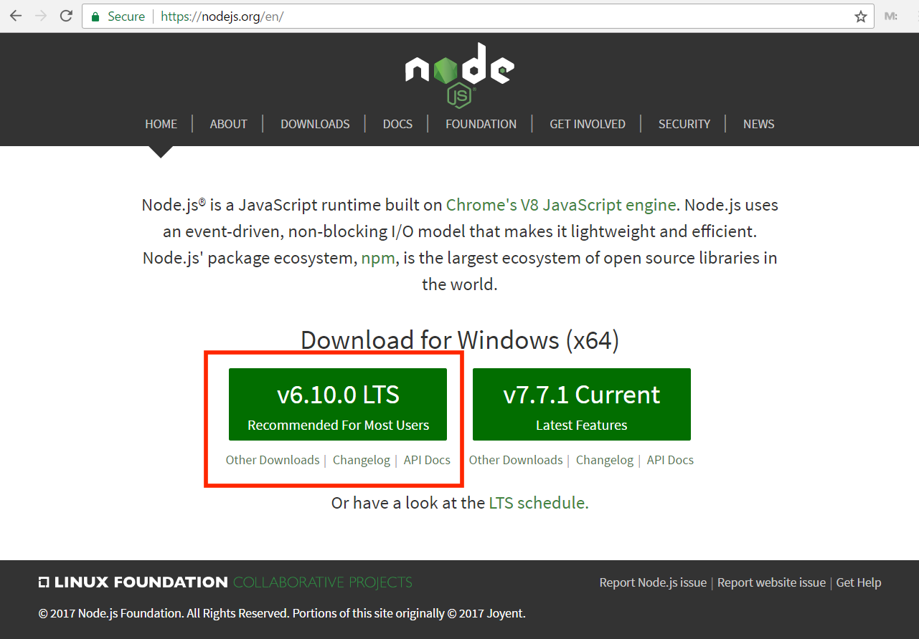

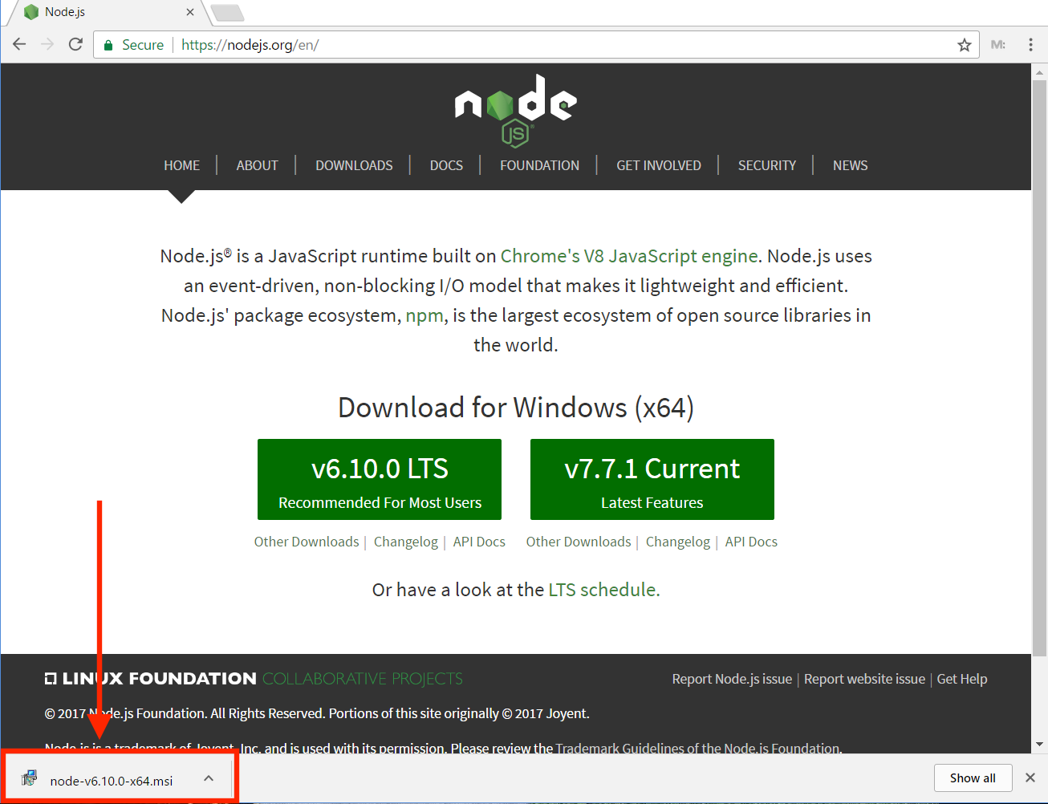

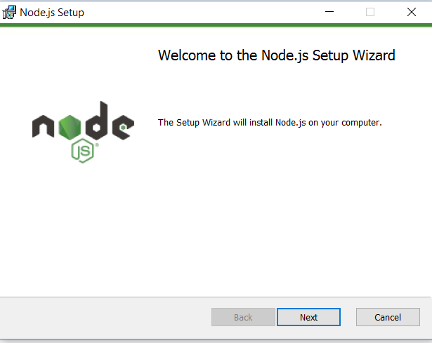

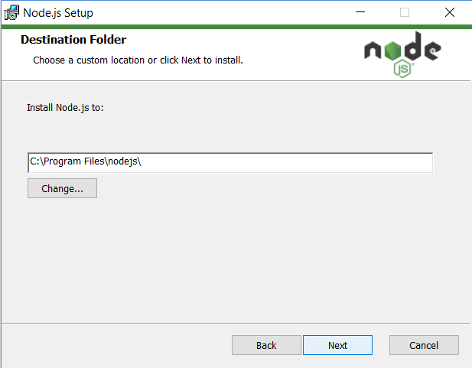

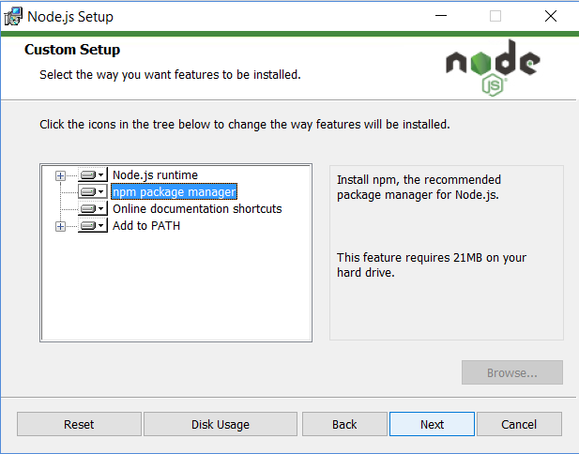

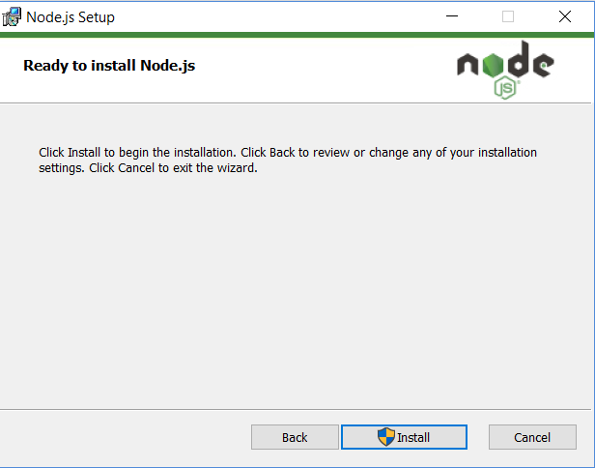

In The Command Prompt. To confirm Node is installed type **node –v** which will print the current version number. To confirm NPM is installed type npm -v which will print its current version number.

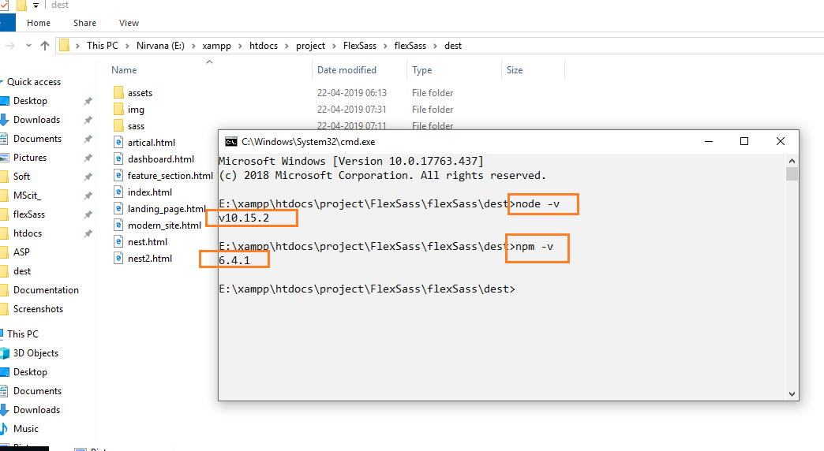

# USER INTERFACE

## What is User Interface Design?

User Interface (UI) Design is the link between users and your website. It includes the basic design elements that need to be present in order to for someone to navigate your site and make decisions. It is the ever-evolving relationship between a person and the system that they are using. It includes the way that your website interacts with users, the overall design and how information is presented.

There are many different ways that you can look at user interface, but the basics always include the communication from a product to the user and vice versa1.

UI Design is all about structure, user manipulation and communication. This is one of the reasons it’s so important that you pay close attention to it. It is the basic building blocks of how your website is set up and functions when visited by your target audience. If it doesn’t go smoothly, problems tend to follow.

Some of the elements involved in User Interface Design include the input controls, navigational components, informational components and containers4. The devil is in the details, as they say. Buttons, lists, toggles, icons, breadcrumbs, tags and more also play a huge role. It is the way that you design your site from the back-end so that your audience can have a seamless, and enjoyable, front-end experience.

### **There are 3 issues / parts of a user interface design, these being**

* + how it looks,
  + how it works,
  + How easy it is to use.

### Key Components of UI/UX Design

There are some core components of UX Design, which are as follows:

* Information Architecture
* Interaction Design
* Usability
* Wire framing
* Visual Design



Src: <https://techterms.com/definition/user_interface>

### Interaction Design

Interaction Design is about creating the conceptual design with which the users interact with the product and/or application. This interaction includes various elements such as aesthetics, color, font, icons, images, motion, sound, space, graphics etc.

### Usability

Usability can be referred as the user-friendliness as well. Along with figuring out if the users get the information they want by using the application or visiting the site for the first time and if the application/website is easy to navigate, the usability also comprehends the ways to handle the errors.

### Wire framing

Wire framing is about creating a sample of the application to test the features, look and usability of the application before it is actually launched. It is a cheap way to test functionality and evaluate if the application serves the purpose.

### Visual Design

Visual design of the application or the website is like defining the company’s brand. Finalizing the visual design can affect the users’ behavior and hence it is the most important component of the UI design. Visual Design is not only about selecting the best images, colors, icons, fonts, but also identifying the appearance of the application impacts the interaction of its users. Now that you are aware with the UI/UX components, we would like to tell you how this whole procedure actually works.

# Screenshots

Login (Teacher, Principal)

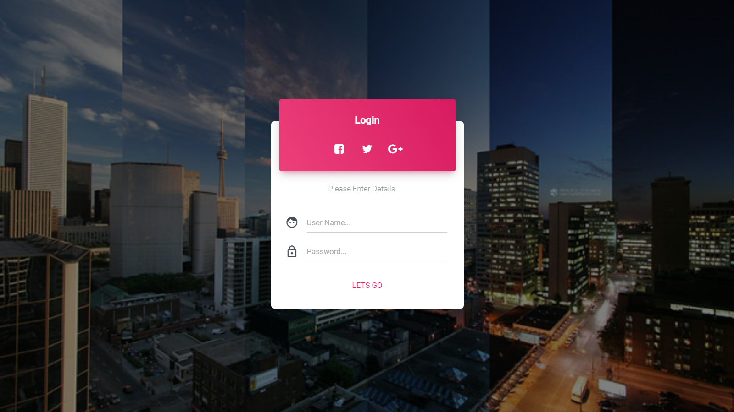

User Must Enter Valid (Username & Password)

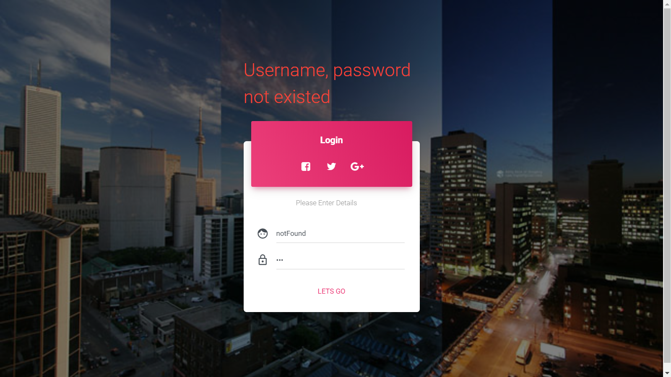

User Must be Logged in before go to dashboard

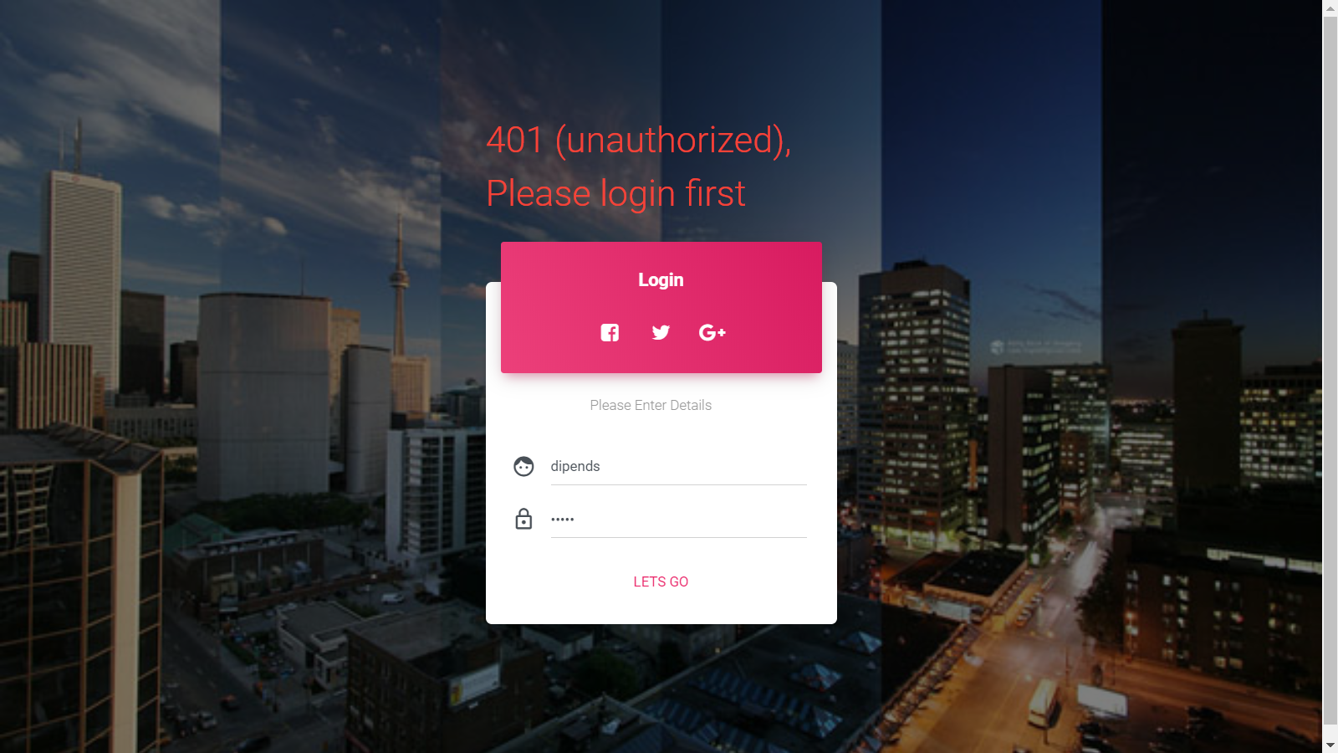

Teacher Registration Form (Principal Only)

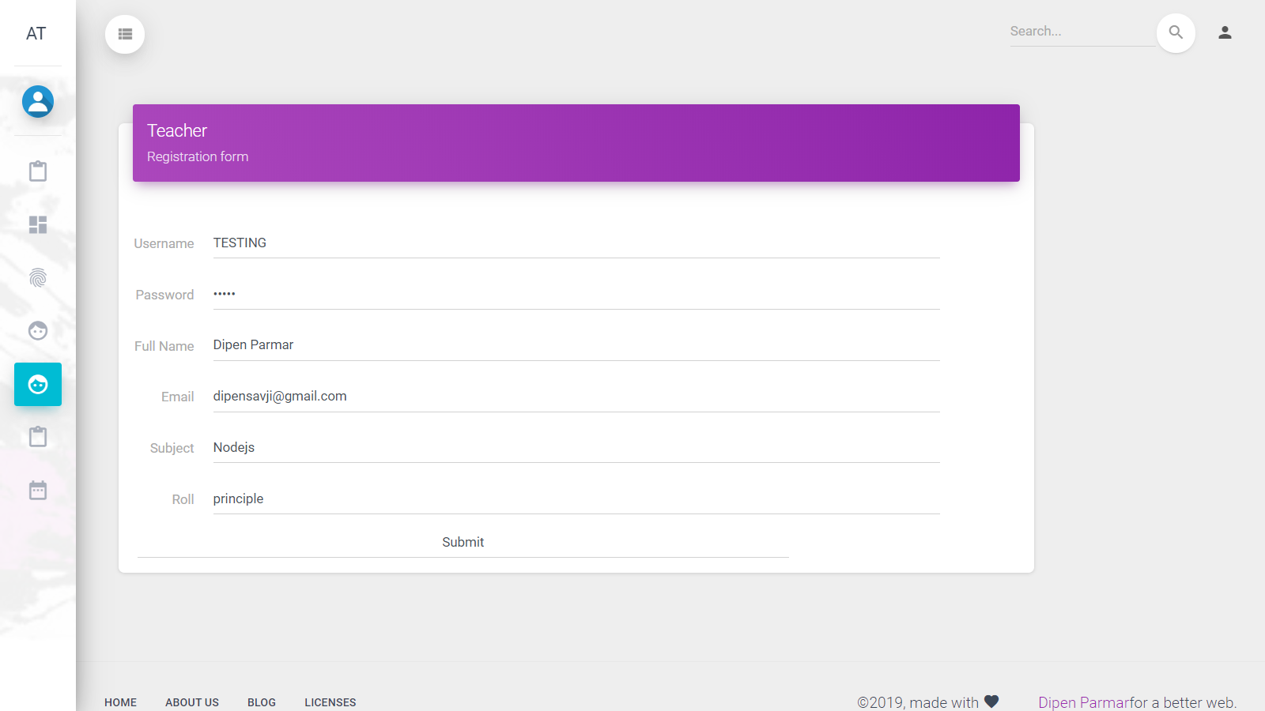

Minimum Required fields (Validation)

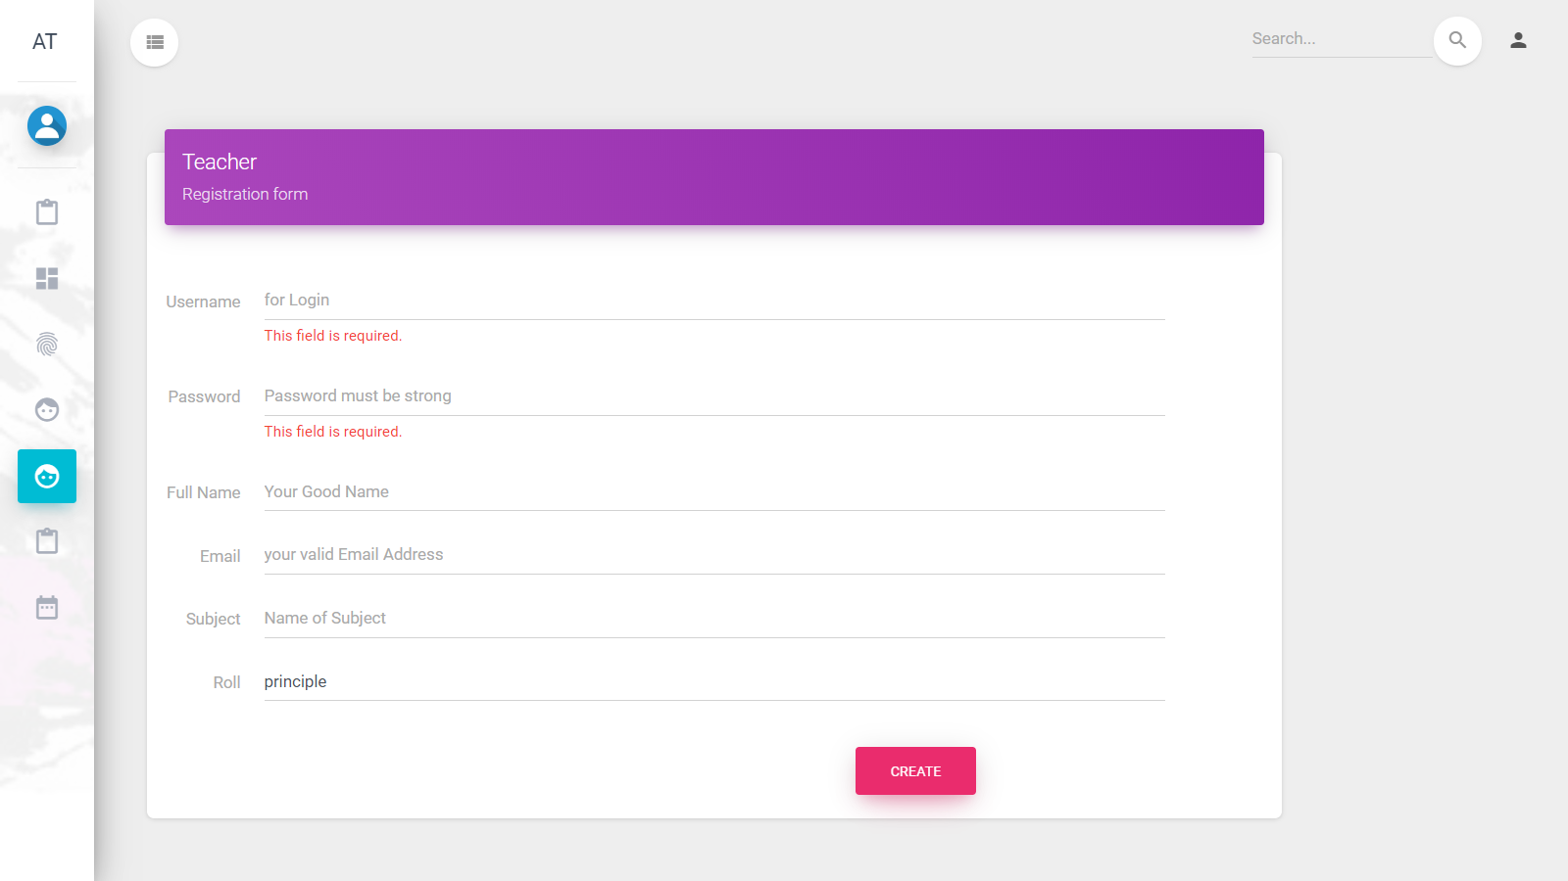

New Teacher Created Successfully notification

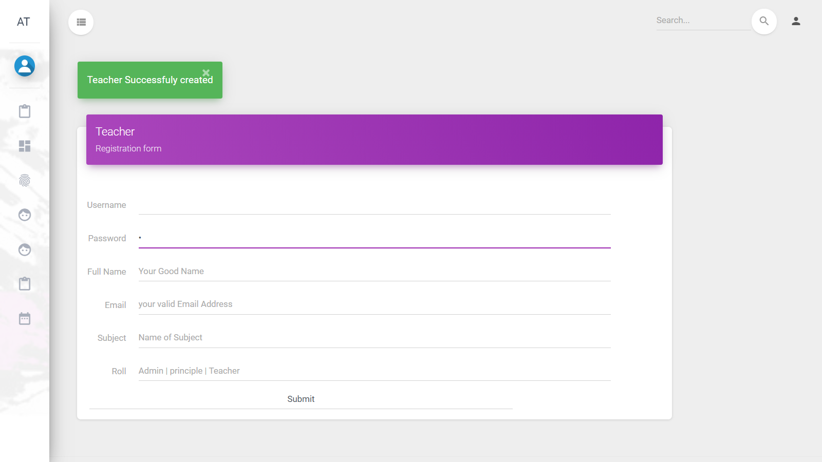

Student Registration form

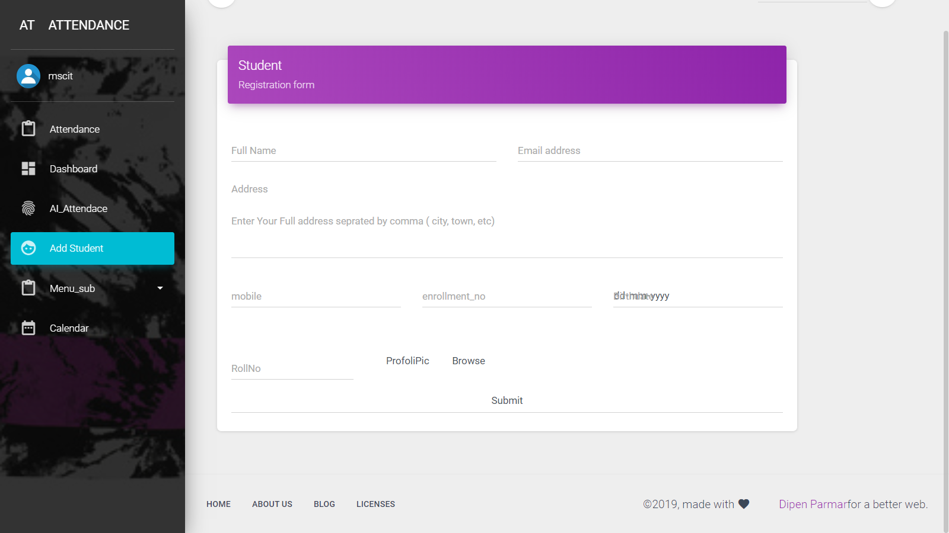

Validations for Student Registration Form

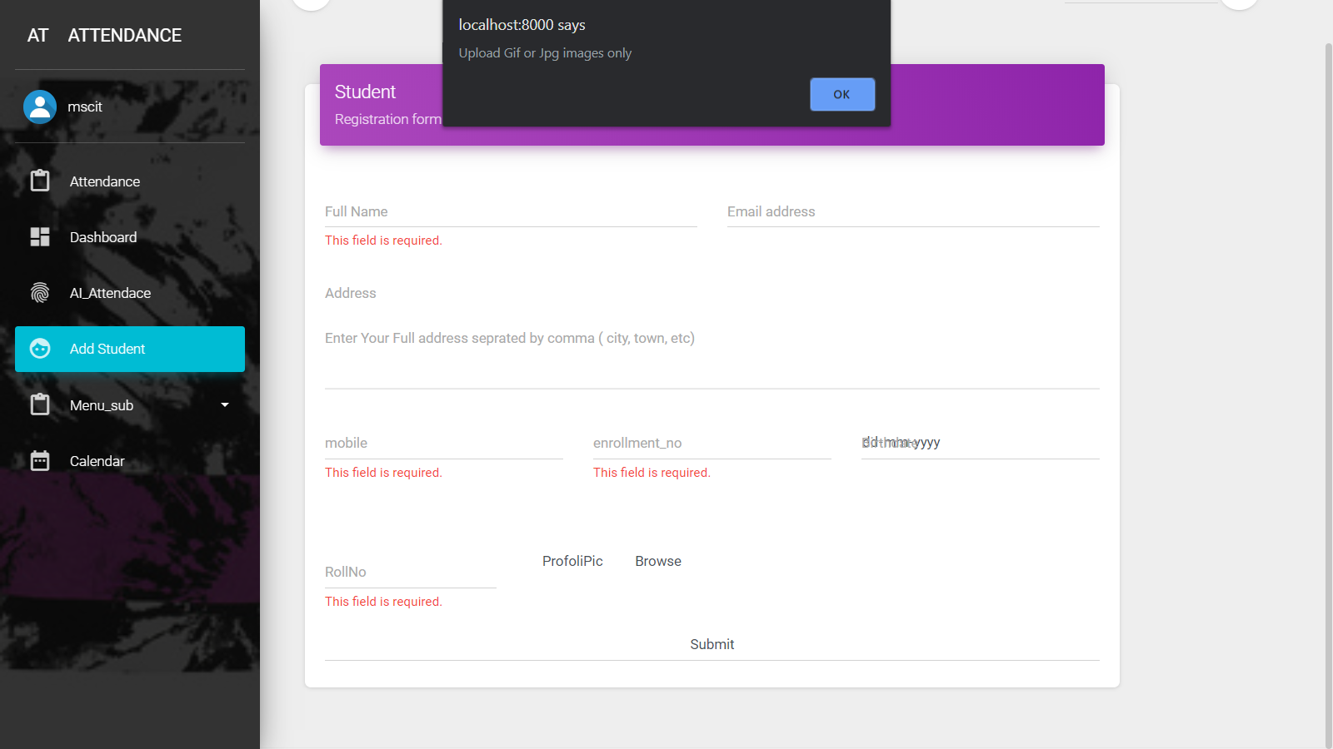

Submit Attendance, Select Absent/Present students by clicking row

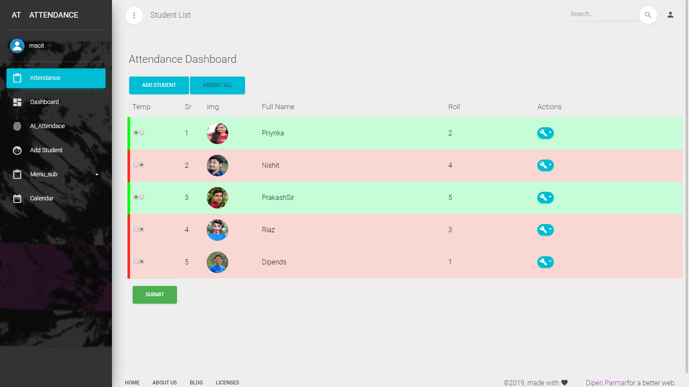

Select Date & cross verify present Students & click on Conform button

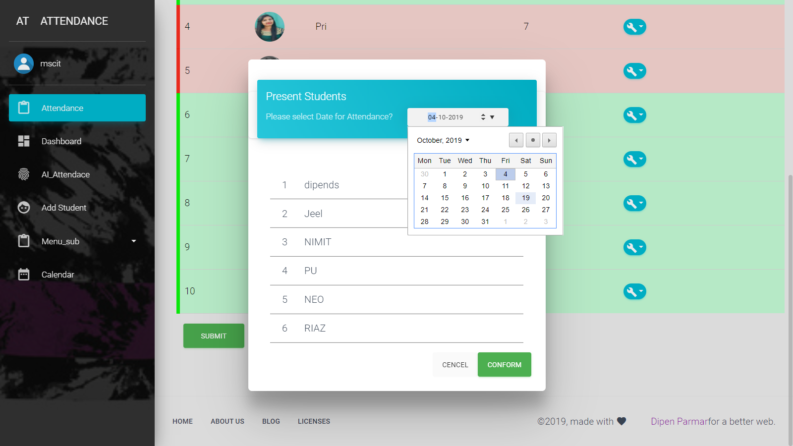

Attendance successfully inserted Notification

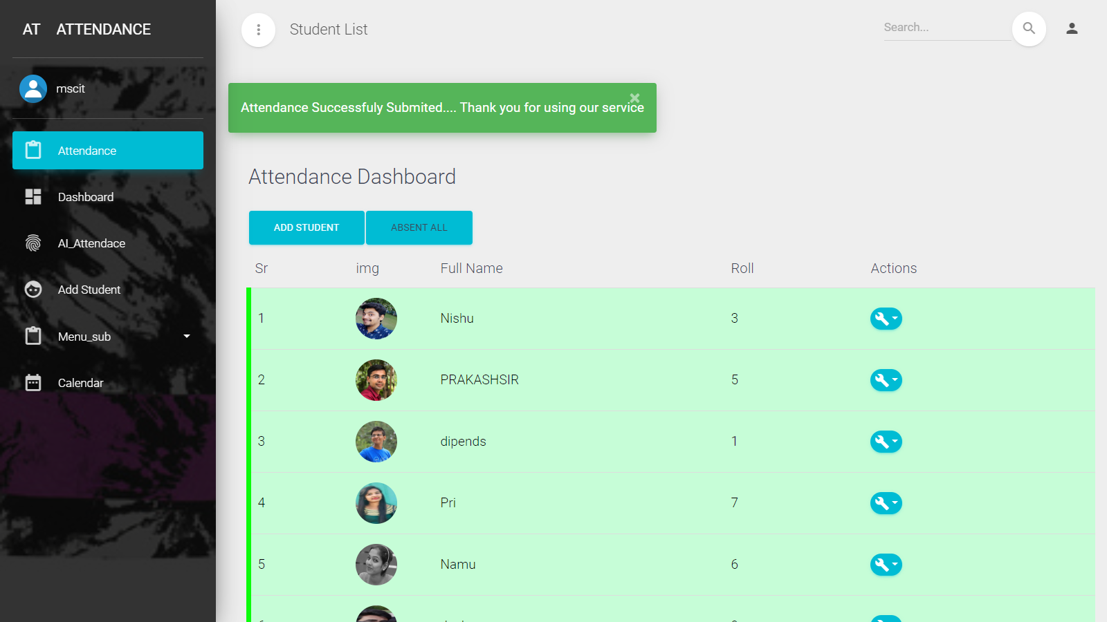

Remove Students in Action column, by clicking Delete button

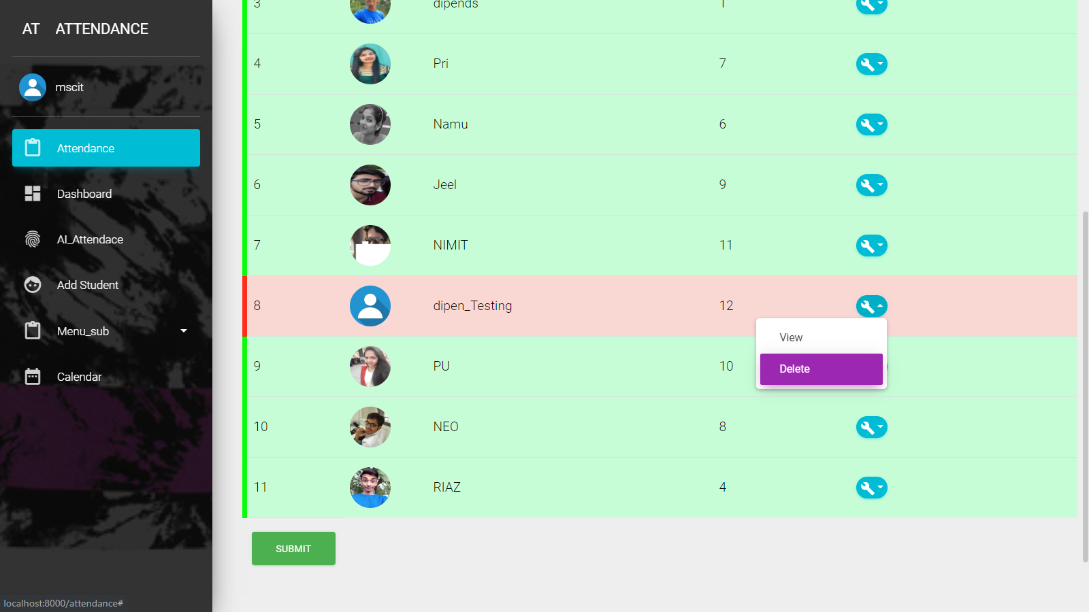

Conformation notification for completing removing student from Database

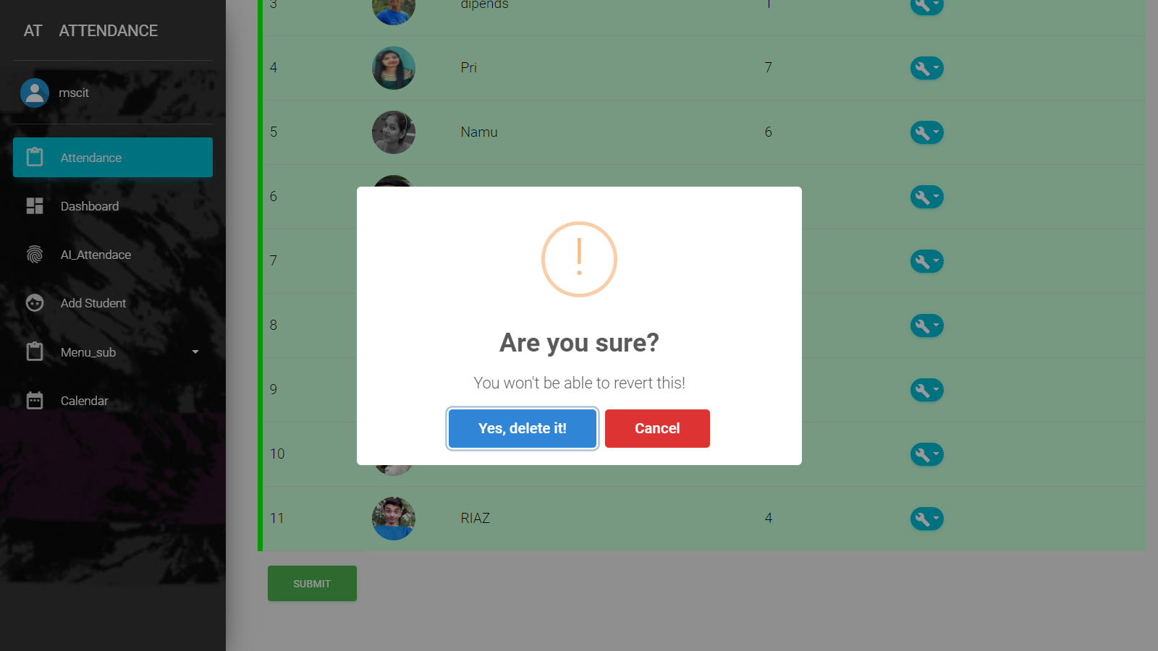

Student Removed from Database Success notification

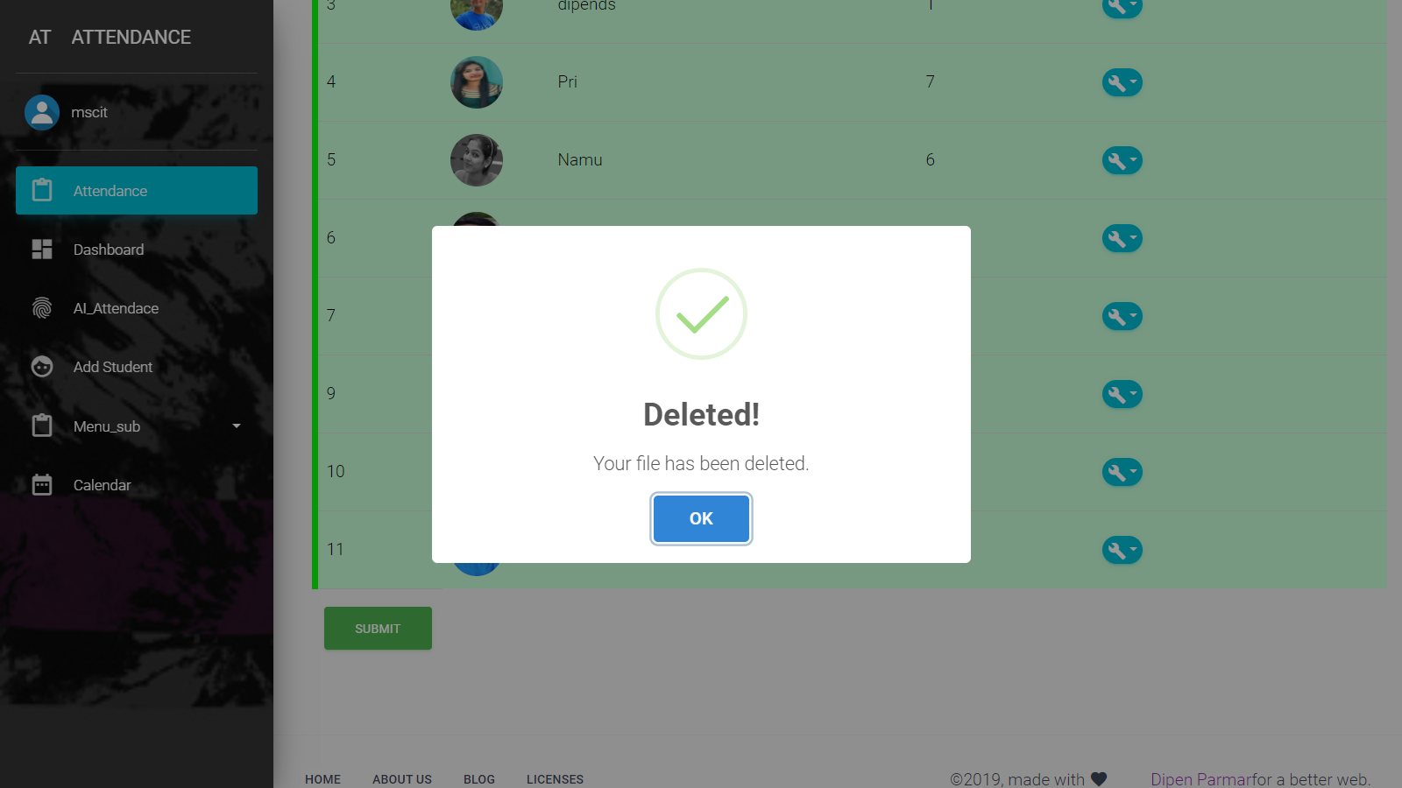

Dashboard Fixed Layout (Present, Absent Both)

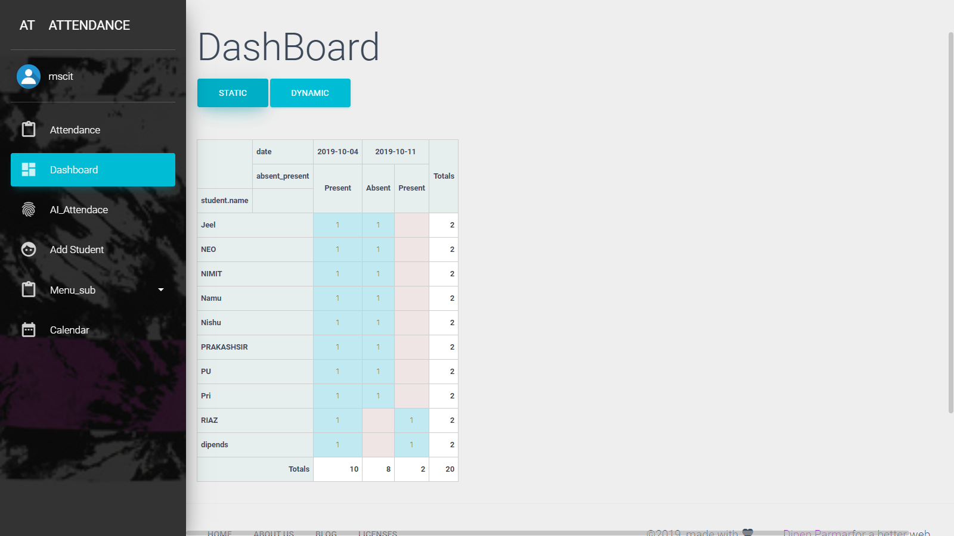

Dynamic Dashboard where user can change, filter values just like Pivot table in Excel

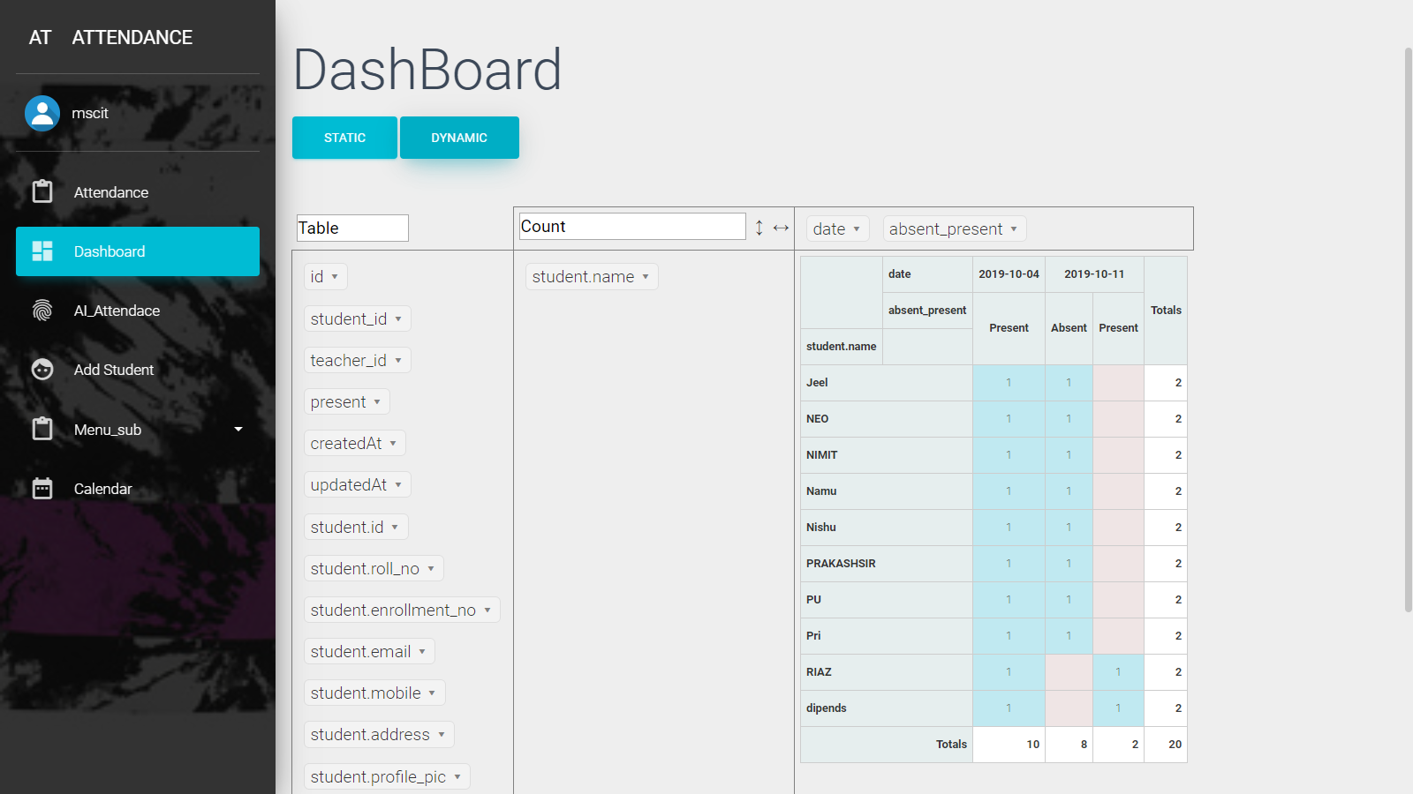

User Friendly UI

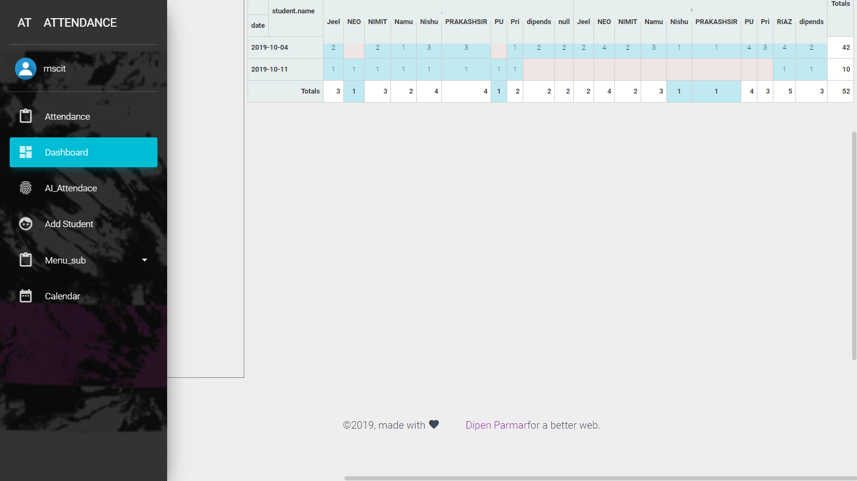

Take Attendance Group photo (AI Attendance) Select Choose file, upload Image

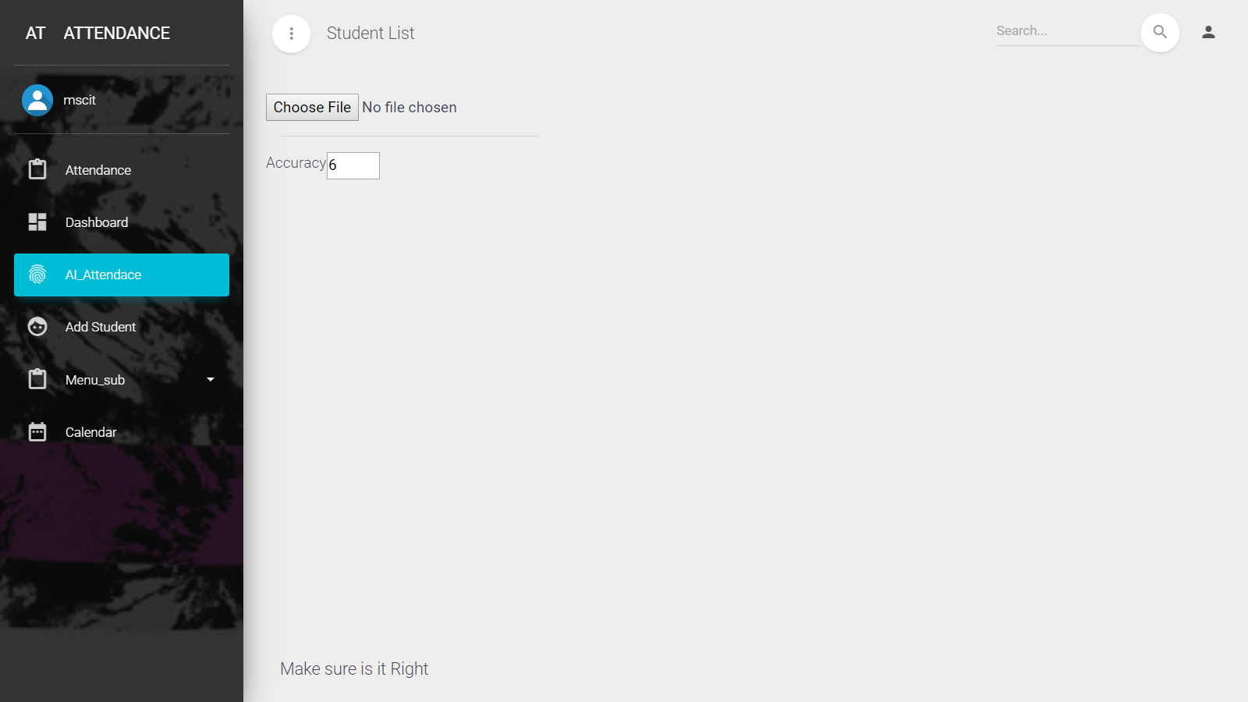

System will Recognition all students existed in uploaded Image by FaceAPI

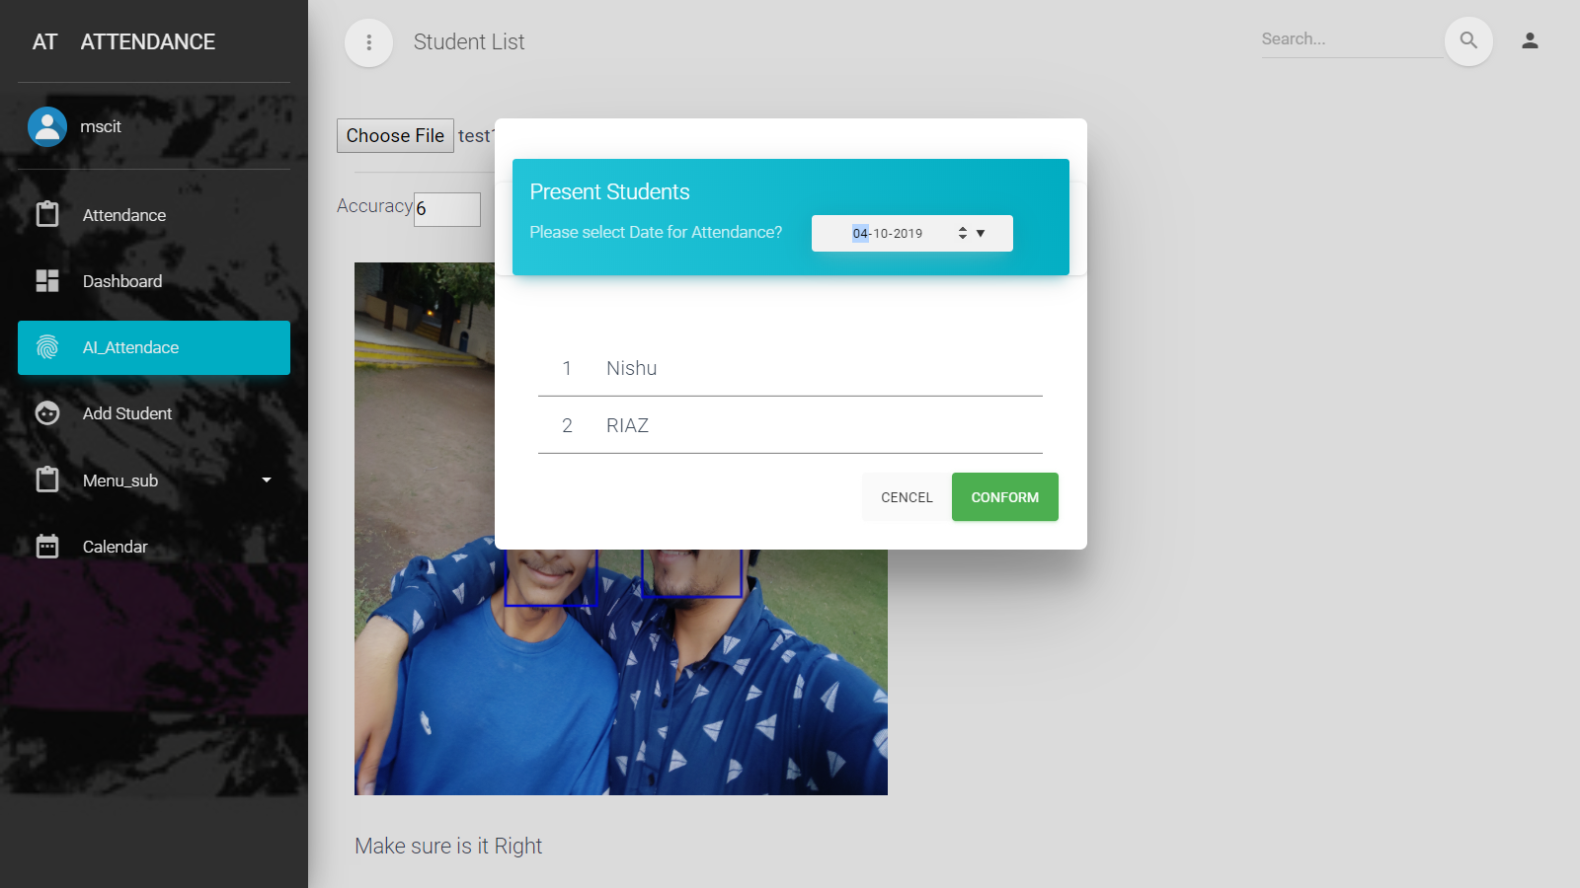

Select Date & click on conform button

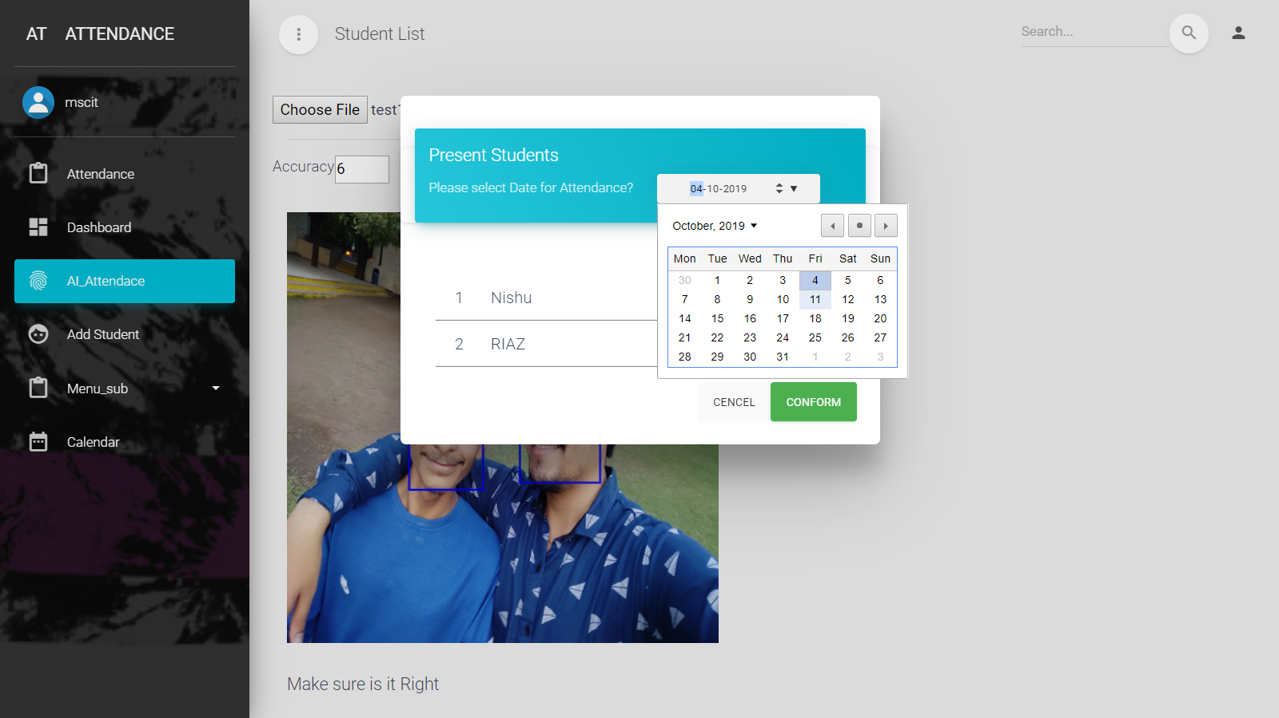

Log out (Signout)

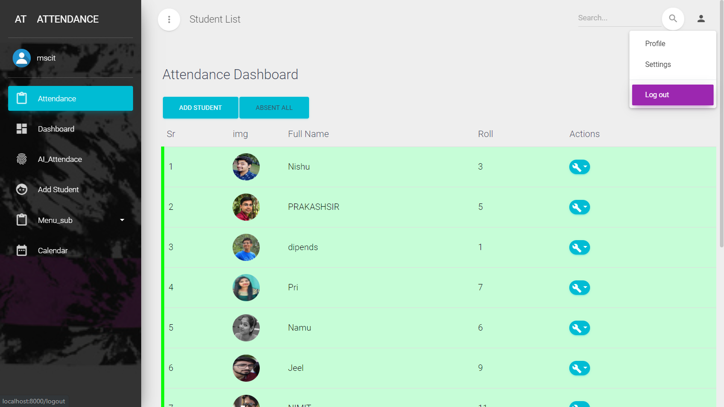

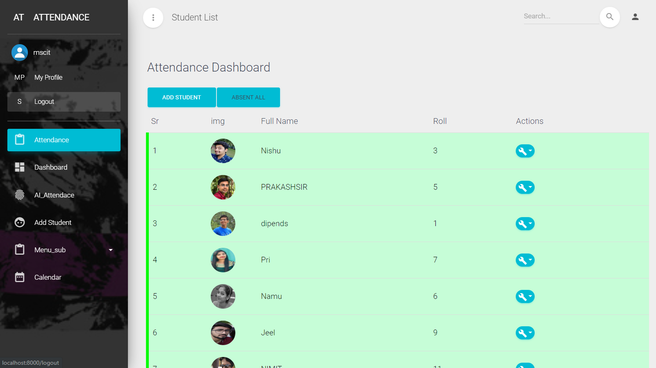

# Data Flow Diagram – DFD

A data flow diagram shows the way information flows through a process or system. It includes data inputs and outputs, data stores, and the various sub processes the data moves through. DFDs are built using standardized symbols and notation to describe various entities and their relationships.

Data flow diagrams visually represent systems and processes that would be hard to describe in a chunk of text. You can use these diagrams to map out an existing system and make it better or to plan out a new system for implementation. Visualizing each element makes it easy to identify inefficiencies and produce the best possible system.

## Physical and logical data flow diagrams

Before actually creating your data flow diagram, you’ll need to determine whether a physical or logical DFD best suits your needs. If you’re new to data flow diagrams, don’t worry—the distinction is pretty straightforward.

Logical data flow diagrams focus on what happens in a particular information flow: what information is being transmitted, what entities are receiving that info, what general processes occur, etc. The processes described in a logical DFD are business activities—a logical DFD doesn’t delve into the technical aspects of a process or system. Non-technical employees should be able to understand these diagrams.

Physical data flow diagrams focus on how things happen in an information flow. These diagrams specify the software, hardware, files, and people involved in an information flow. A detailed physical data flow diagram can facilitate the development of the code needed to implement a data system.

## Symbols and Notations Used in DFDs

Two common systems of symbols are named after their creators:

* Yourdon and Coad
* Yourdon and DeMarco
* Gane and Sarson

One main difference in their symbols is that Yourdon-Coad and Yourdon-DeMarco use circles for processes, while Gane and Sarson use rectangles with rounded corners, sometimes called lozenges. There are other symbol variations in use as well, so the important thing to keep in mind is to be clear and consistent in the shapes and notations you use to communicate and collaborate with others.

Using any convention’s DFD rules or guidelines, the symbols depict the four components of data flow diagrams.

1. **External entity**: an outside system that sends or receives data, communicating with the system being diagrammed. They are the sources and destinations of information entering or leaving the system. They might be an outside organization or person, a computer system or a business system. They are also known as terminators, sources and sinks or actors. They are typically drawn on the edges of the diagram.

2. **Process**: any process that changes the data, producing an output. It might perform computations, or sort data based on logic, or direct the data flow based on business rules. A short label is used to describe the process, such as “Submit payment.”

3. **Data store**: files or repositories that hold information for later use, such as a database table or a membership form. Each data store receives a simple label, such as “Orders.”

4. **Data flow**: the route that data takes between the external entities, processes and data stores. It portrays the interface between the other components and is shown with arrows, typically labeled with a short data name, like “Billing details.”

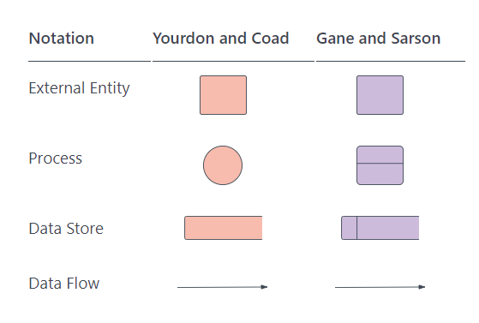

DFD rules and tips

* Each process should have at least one input and an output.
* Each data store should have at least one data flow in and one data flow out.
* Data stored in a system must go through a process.
* All processes in a DFD go to another process or a data store.

Src: <https://www.lucidchart.com/pages/data-flow-diagram>

Src: <https://www.lucidchart.com/blog/data-flow-diagram-tutorial>

## Data flow diagram Systema Asistencia

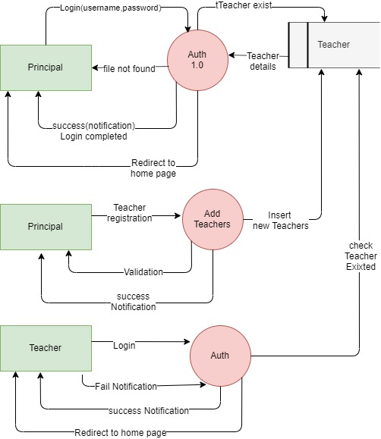

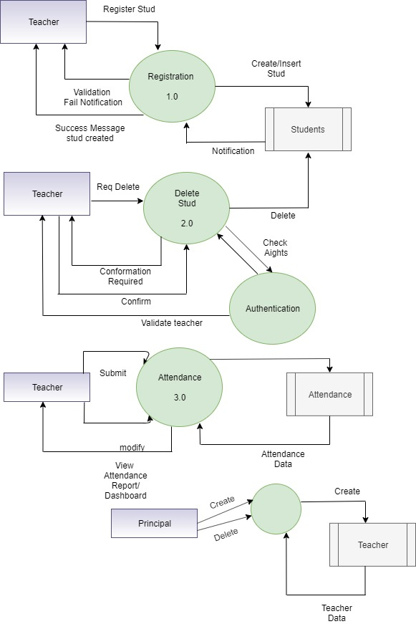

# Data Dictionary

Data dictionary: is a file or a set of files that contains a database's metadata. The data dictionary contains records about other objects in the database, such as data ownership, data relationships to other objects, and other data.

The data dictionary is a crucial component of any relational database. Ironically, because of its importance, it is invisible to most database users. Typically, only database administrators interact with the data dictionary.

In a relational database, the metadata in the data dictionary includes the following:

* Names of all tables in the database and their owners
* Names of all indexes and the columns to which the tables in those indexes relate
* Constraints defined on tables, including primary keys, foreign-key relationships to other tables, and not-null constraints

For most relational database management systems (RDBMS), the database management system software needs the data dictionary to access the data within a database. For example, the Oracle DB software has to read and write to an Oracle DB. However, it can only do this via the data dictionary created for that particular database.

Src: <https://www.techopedia.com/definition/27752/data-dictionary>

## Teachers:

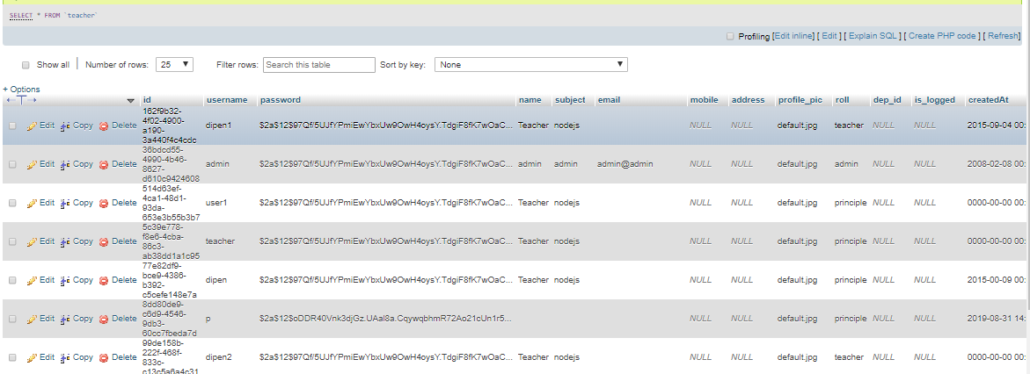

## Students:

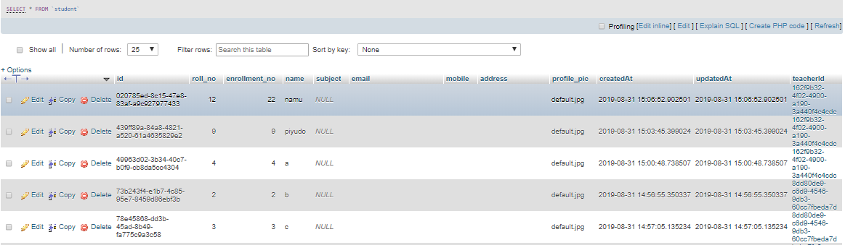

## Attendance:

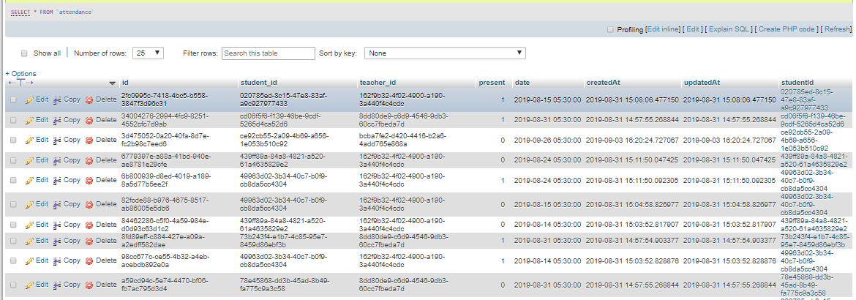

# PUG

## What is Pug | Jade

Pug.js is a HTML templating engine, which means you can write much simpler Pug code, which Pug compiler will compile into HTML code, that browser can understand. ... Pug has powerful features like conditions, loops, includes, mixins using which we can render HTML code based on user input or reference data

## Pug.js to make your life easier with HTML templates

Pug.js is a HTML templating engine, which means you can write much simpler Pug code, which Pug compiler will compile into HTML code, that browser can understand. But why not write HTML code in the first place?

Pug has powerful features like conditions, loops, includes, mixins using which we can render HTML code based on user input or reference data. Pug also support JavaScript natively, hence using JavaScript expressions, we can format HTML code.

Pug.js, as from its name is a JavaScript library. Hence, we can run it inside browser or on node.js. Here, I am using node.js to demonstrate few examples.

This Gulp plugin enables you to compile your Pug templates into HTML or JS, with support for template locals, custom Pug filters, AMD wrapping, and others. Here is a simple example using gulp-pug:

Pug is available via npm (GULP):

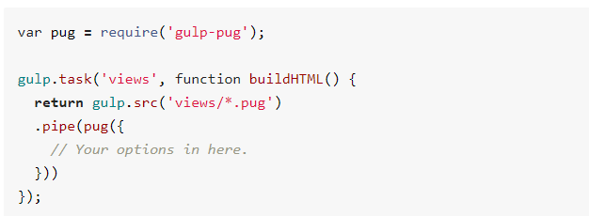

## Let’s see how pug code looks like.

## PUG Structure | index.pug vs. index.html

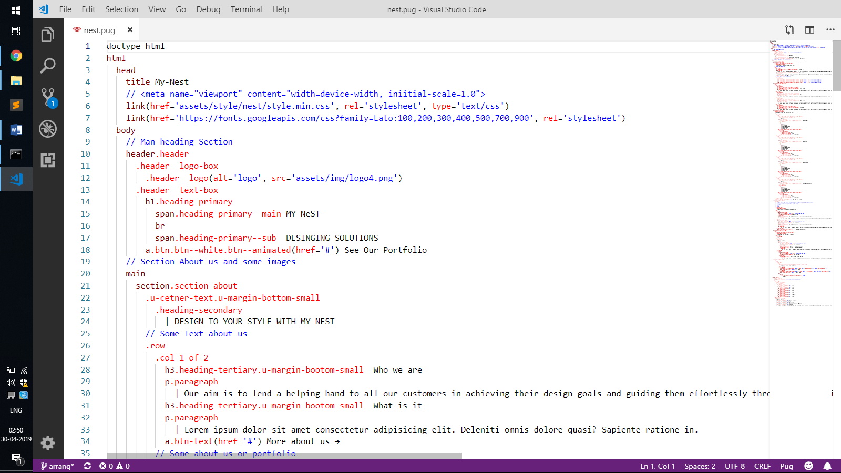 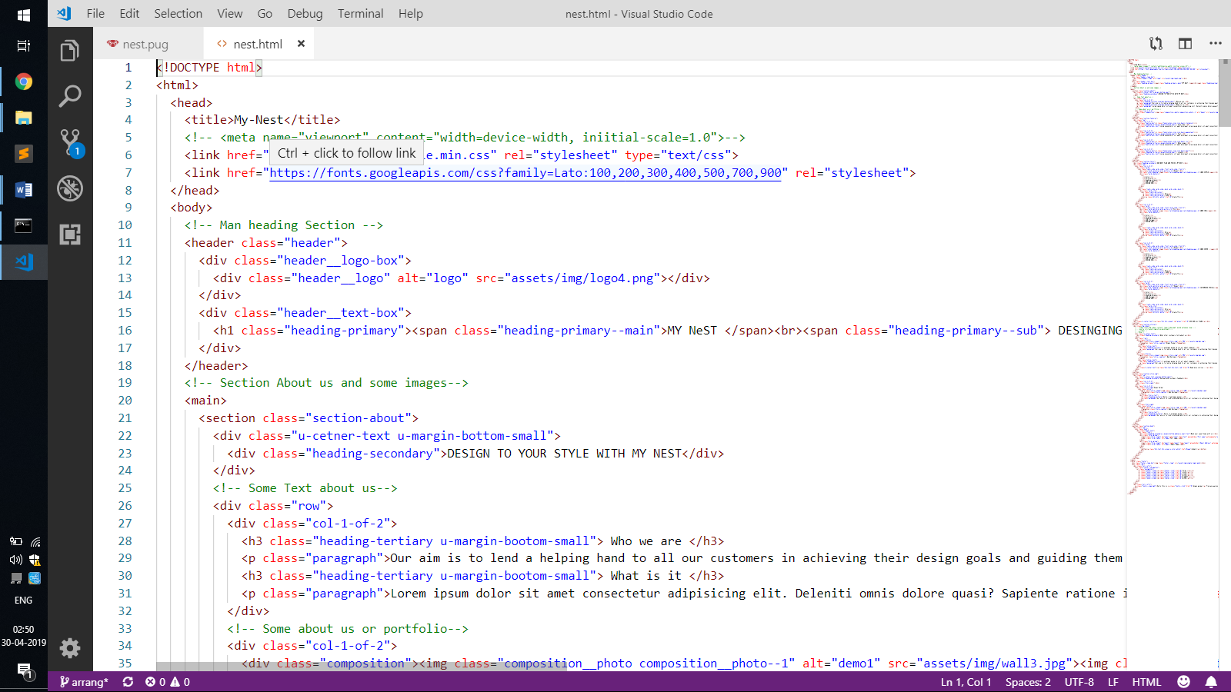

# Frameworks & Libraries

## Express js

Express.js, or simply Express, is a web application framework for Node.js, released as free and open-source software under the MIT License. It is designed for building web applications and APIs. It has been called the de facto standard server framework for Node.js.

The original author, TJ Holowaychuk, described it as a Sinatra-inspired server[citation needed], meaning that it is relatively minimal with many features available as plugins. Express is the back-end component of the MEAN stack, together with the MongoDB database software and AngularJS front-end framework

## TypeORM

TypeORM is an ORM that can run in NodeJS, Browser, Cordova, Phone Gap, Ionic, React Native, Native Script, Expo, and Electron platforms and can be used with Typescript and JavaScript (ES5, ES6, ES7, and ES8). Its goal is to always support the latest JavaScript features and provide additional features that help you to develop any kind of application that uses databases - from small applications with a few tables to large scale enterprise applications with multiple databases.

TypeORM supports both Active Record and Data Mapper patterns, unlike all other JavaScript ORMs currently in existence, which means you can write high quality, loosely coupled, and scalable, maintainable applications the most productive way.

TypeORM is highly influenced by other ORMs, such as Hibernate, Doctrine and Entity Framework.

## JWT

JSON Web Token (JWT, sometimes pronounced) is an Internet standard for creating JSON-based access tokens that assert some number of claims. For example, a server could generate a token that has the claim "logged in as admin" and provide that to a client. The client could then use that token to prove that it is logged in as admin. The tokens are signed by one party's private key (usually the server's), so that both parties (the other already being, by some suitable and trustworthy means, in possession of the corresponding public key) are able to verify that the token is legitimate. The tokens are designed to be compact, URL-safe, and usable especially in a web-browser single-sign-on (SSO) context. JWT claims can be typically used to pass identity of authenticated users between an identity provider and a service provider, or any other type of claims as required by business processes

## FaceAPI

Face-api.js is a JavaScript API for face detection and face recognition in the browser implemented on top of the tensorflow.js core API. It implements a series of convolutional neural networks (CNNs), optimized for the web and for mobile devices.

## TypeScript

TypeScript is an open-source programming language developed and maintained by Microsoft. It is a strict syntactical superset of JavaScript, and adds optional static typing to the language.

TypeScript is designed for development of large applications and trans compiles to JavaScript.[5] As TypeScript is a superset of JavaScript, existing JavaScript programs are also valid TypeScript programs. TypeScript may be used to develop JavaScript applications for both client-side and server-side (Node.js) execution.

TypeScript originated from the shortcomings of JavaScript for the development of large-scale applications both at Microsoft and among their external customers. Challenges with dealing with complex JavaScript code led to demand for custom tooling to ease developing of components in the language

________________ Date:: 18.July.2019 ________________

---------------(Nodejs sequelize bulk insert) Customizing the Laravel View Path -

'paths' => [

resource_path('views'),

app_path('views'),

],

Src: <https://laravel-news.com/laravel-view-path>

________________ Date:: 19.July.2019 ________________

---------------( express get id in routes) Express router - :id?

This is an express middleware.

In this case, yes, it will route /todos/anything, and then req.params.id will be set to 'anything'

Src: <https://stackoverflow.com/questions/34095126/express-router-id>

________________ Date:: 20.Jul.2019 ________________

---------------(sequelize insert new record) insert a new record in nodejs using sequelize POST methodSrc:

// parse application/x-www-form-urlencoded

app.use(bodyParser.urlencoded({ extended: false }))

// parse application/json

app.use(bodyParser.json())

app.post('/test', function (request, response) {

return users.create({

id: request.body.id,

name: request.body.name,

role: request.body.role,

email: request.body.email

}).then(function (users) {

if (users) {

response.send(users);

} else {

response.status(400).send('Error in insert new record');

}

});

});

______________ Date:: 22.Jul.2019 ________________

---------------(node js fetch json data to const) Reading JSON in Node.js

const http = require('http');

let req = http.get("http://localhost:8000/data.json", function(res) {

let data = '',

json_data;

res.on('data', function(stream) {

data += stream;

});

res.on('end', function() {

json_data = JSON.parse(data);

// will output a Javascript object

console.log(json_data);

});

});

req.on('error', function(e) {

console.log(e.message);

});

Src: <https://usefulangle.com/post/109/nodejs-read-json>

________________ Date:: 23.Jul.2019 ________________

---------------(sequelizejs catch error) Where to handle the error in a sequelize ORM query statement?

models.Item.create({

title : req.body.title,

UserId : req.body.UserId

}).then(function(item){

res.json({

"Message" : "Created item.",

"Item" : item

});

}).catch(function (err) {

// handle error;

});

Src: <https://stackoverflow.com/questions/35337738/where-to-handle-the-error-in-a-sequelize-orm-query-statement>

________________ Date:: 24.Jul.2019 ________________

---------------(pug loop Example ) Pug loop – CodePen

-

list = [{id:1, img:'', name:'dipen pamar'},{id:2, img:'', name:'Parmar'}]

h1 Simple Loop Example (PUG)

ul

each val,i in list

li=i + ", id: " + val.id + ", name: " + val.name

Src: <https://codepen.io/monochromer/pen/VWvvee>

________________ Date:: 24.Jul.2019 ________________

---------------(sequelize foreign key set) Sequelize.js foreign key

var Person = sequelize.define('Person', {

name: Sequelize.STRING

});

var Father = sequelize.define('Father', {

age: Sequelize.STRING,

//The magic start here

personId: {

type: Sequelize.INTEGER,

references: 'persons', // <<< Note, its table's name, not object name

referencesKey: 'id' // <<< Note, its a column name

}

});

Person.hasMany(Father); // Set one to many relationship

Src: <https://stackoverflow.com/questions/14169655/sequelize-js-foreign-key>

________________ Date:: 25.Jul.2019 ________________

---------------(html tr onclick checkbox js) click anywhere on a table row and it will check the checkbox its in…?

document.querySelector("table").addEventListener("click", ({target}) => {

// discard direct clicks on input elements

if (target.nodeName === "INPUT") return;

// get the nearest tr

if (tr) {

// if it exists, get the first checkbox

const checkbox = tr.querySelector("input[type='checkbox']");

if (checkbox) {

// if it exists, toggle the checked property

checkbox.checked = !checkbox.checked;

}

}

});

Src: <https://stackoverflow.com/questions/5833152/click-anywhere-on-a-table-row-and-it-will-check-the-checkbox-its-in>

________________ Date:: 26.Jul.2019 ________________

---------------(css select multiple attribute values) Specify multiple attribute selectors in CSS

Concatenate the attribute selectors:

input[name=Sex][value=M]

input[name="Sex"][value="M"]

Src: <https://stackoverflow.com/questions/12340737/specify-multiple-attribute-selectors-in-css>

________________ Date:: 26.Jul.2019 ________________

---------------( javascript check object attribute exists ) How to check if object property exists with a variable holding the property name? [duplicate]

if('prop' in myObj){

alert("yes, i have that property");

}

Src: <https://stackoverflow.com/questions/11040472/how-to-check-if-object-property-exists-with-a-variable-holding-the-property-name>

________________ Date:: 27.Jul.2019 ________________

---------------(sequelizejs store findAll data to let variable) Get only dataValues from Sequelize ORM

const users = await db.users.findAll({})

.map(el => el.get({ plain: true })) // add this line to code

Src: <https://stackoverflow.com/questions/46380563/get-only-datavalues-from-sequelize-orm>

---------------( JS nested object to flat ) Flatten javascript objects into a single-depth object

flattenObject: (ob) => {

var toReturn = {};

for (var i in ob) {

if (!ob.hasOwnProperty(i)) continue;

if ((typeof ob[i]) == 'object') {

var flatObject = flattenObject(ob[i]);

for (var x in flatObject) {

if (!flatObject.hasOwnProperty(x)) continue;

toReturn[i + '.' + x] = flatObject[x];

}

} else {

toReturn[i] = ob[i];

}

}

return toReturn;

}

Src: <https://gist.github.com/penguinboy/762197>

________________ Date:: 31.Jul.2019 ________________

---------------( get empty all values in html javascript ) Clear all HTML fields using javascript

$("input,input[type=text],textarea,input[type=email]").val('');

Src: <https://stackoverflow.com/questions/569357/clear-all-html-fields-using-javascript>

________________ Date:: 1.Aug.2019 ________________

---------------( target parent child of selected child ) jQuery: How to get to a particular child of a parent?

$(".mylink").closest(".box").find('[class*="something"]').first().attr("id")

$(this).closest('.box').children('.something1')

$(this).parent().siblings(".something1");

$(this).parents(".box").children(".something1");

$(this).parent().prev(); // if you always want the parent's previous sibling

Src: <https://stackoverflow.com/questions/2398947/jquery-how-to-get-to-a-particular-child-of-a-parent>

________________ Date:: 20.Aug.2019 ________________

---------------(typeorm export module connection manager) Complete guide to using TypeORM and TypeScript for data persistence in Node.js module

* OOPs with TypeORM Example Explained very well

Src: <https://levelup.gitconnected.com/complete-guide-to-using-typeorm-and-typescript-for-data-persistence-in-node-js-module-bfce169959d9>

Src: <https://techsparx.com/nodejs/typescript/typeorm.html>

________________ Date:: 22.Aug.2019 ________________

---------------(Access current Request in Express Jade/ PUG) Google Title

var path = window.location.pathname;

$("a.nav-link[href='"+path+"']").parents('li.nav-item').addClass('active')

Src: /

________________ Date:: 2.Oct.2019 ________________

---------------(nodejs use Dirent ifFile) Node.js check if path is file or directory

fs.lstatSync(path_string).isDirectory() should tell you. From the [docs](https://nodejs.org/docs/latest/api/fs.html#fs_class_fs_stats):

stats.isFile()

stats.isDirectory()

stats.isFIFO()

stats.isSocket()

Src: <https://stackoverflow.com/questions/15630770/node-js-check-if-path-is-file-or-directory>